Sorting Algorithm Efficiency Comparison in Resource-Limited Microcontrollers and Edge Devices
L Mokshana (Enrollment No. 92400118795 Division 5EN14,CSE AIML).

Abstract
Sorting is one of the most common operations that resource-limited microcontrollers and edge devices perform locally, for ordering sensor readings, filtering by rank, prioritising queues and preparing data for aggregation. Asymptotic complexity does not tell a designer which algorithm will fit and run well on a device with a few kilobytes of SRAM, because it ignores auxiliary memory, recursion depth, input order, timing variation and energy. This paper (i) reviews seven studies that benchmark, accelerate or adapt sorting on constrained, embedded and hardware platforms, (ii) synthesises their published measurements, and (iii) specifies a reproducible benchmark and a multi-metric decision framework for comparing six classical algorithms (Bubble, Insertion, Selection, Merge, Quick and Heap Sort) on 8-bit AVR boards, 32-bit microcontrollers and edge computers. The benchmark firmware and analysis code are supplied with the paper. The numerical results reported here are published values from the reviewed studies, not new measurements. On three 8-bit AVR boards, the reference study reports that Heap Sort sorted 1,000 random integers in about 92 ms using about 12 to 13 bytes of extra SRAM, roughly 21 times faster than Bubble Sort, whereas Merge Sort needed about 2 KB of extra SRAM and Quick Sort failed on ordered input. Studies on FPGA and Intel i7 platforms, flash-based external sorting, adaptive selection and threshold-based partial sorting show that the best algorithm changes with array size, hardware tier, memory budget, data distribution and the timing-stability requirement. We therefore recommend selecting an algorithm by feasibility, time, memory, energy, writes and stability together, not by speed alone. The paper's own hardware measurements remain to be collected with the supplied benchmark.
Keywords: sorting algorithms, microcontrollers, edge computing, SRAM, energy efficiency, Heap Sort, Arduino, benchmarking, FPGA.

1. Introduction
Embedded devices are built to minimise cost, so designers choose the smallest CPU and memory that will do the job. When such a device must also process the data it collects, the resources left over are very limited. Processing data close to the sensor reduces network transmissions, saves energy and gives a faster response [2], [14]. A common processing task is sorting, which is used for ordering output, aggregation, calculations and data linking [2]. In sensor networks, aggregation before transmission reduces the amount of data sent, and sort-based aggregation requires sorting [2], [14].
Conventional analysis of sorting algorithms relies on asymptotic time complexity: O(n²) for Bubble, Insertion and Selection Sort and O(n log n) for Merge, Quick and Heap Sort. This framing assumes abundant memory and a cheap auxiliary buffer. On a microcontroller with 2 KB of SRAM, an O(n log n) algorithm that needs O(n) extra memory may not run at all, while a slower in-place algorithm may be the only one that fits. A recent empirical study on three 8-bit AVR Arduino boards confirms that time complexity alone cannot predict practical suitability and that memory use, input order and write activity must be measured on real hardware [1].
The wider literature points the same way from different directions. Flash-aware external sorting reduces the memory needed to sort data that does not fit in RAM [2]. Hardware comparisons on FPGA and Intel i7 platforms show that the ranking of sorting algorithms changes with array size and with the platform, and that timing variation can matter as much as the mean [4]. Machine-learning-guided selection chooses among algorithms from data features [3]. Threshold-based partial sorting avoids sorting the whole data set when only a subset is needed [5]. A survey of hardware sorting treats energy, resource limits and data movement as open challenges [6]. Statistical comparisons on desktop-class machines add modern algorithms such as Tim Sort and Intro Sort [7]. No single study reviewed here combines multi-tier hardware, direct energy measurement, sensor-like workloads and an explicit decision framework. This paper reviews these studies, identifies the gap, and provides a benchmark and decision framework to close it.

1.1 Challenges in Existing Sorting Evaluation
- Memory decides feasibility. An algorithm that needs O(n) auxiliary memory can fail outright on the smallest boards, as Merge Sort did in the 8-bit study [1].
- Input order changes the ranking. Quick Sort was fastest on random data but failed on ordered data, while Bubble and Insertion Sort became very fast on already-sorted data [1]. The best algorithm also changed with array size on an Intel i7 [4].
- Mean time hides instability. On the Intel i7, the relative standard deviation of Quick Sort reached 209.8% at 4,096 elements, which makes its worst case unsuitable for real-time use even though other statistics looked acceptable [4].
- Energy is rarely measured directly. The 8-bit study counts array writes as a proxy for energy [1], and a hardware-sorting survey lists power and energy among the open challenges [6].
- Platforms and workloads are not comparable. The studies reviewed use different hardware (8-bit boards, a laptop CPU, an FPGA, desktop machines), different units and different data, so their numbers cannot simply be merged [1], [4], [7].
- Data may not fit in RAM. The in-memory benchmark of [1] does not cover sorting from flash or SD storage, which is the problem addressed in [2].

1.2 Research Contributions
- A detailed review and comparison of seven studies on sorting for constrained, embedded and hardware platforms, with a gap analysis (Section 2).
- A benchmark design and firmware (sorting_benchmark.ino) that implements six classical algorithms and measures time, array writes and peak SRAM with a two-way correctness check, plus an analysis script (analyze_results.py) that produces ten graphs (Section 3).
- A mapping from the acknowledged limitations of the 8-bit reference study to specific extensions: more hardware tiers, direct energy measurement, sensor-like workloads, temporal stability and an optional external-memory mode.
- A staged, multi-metric decision framework with an explicit weighted score, so that the "best" algorithm is defined for a given device and workload instead of being declared universal (Sections 3.5 and 3.7).
- A synthesis of the published results of the reviewed studies, with three figures redrawn from their reported numbers (Section 4).

1.3 Motivation
Designers of IoT nodes choose a sorting routine under tight limits on memory, energy and timing. Textbook advice favours O(n log n) algorithms, but the evidence reviewed here shows that the right choice depends on the device and the data. On the smallest AVR boards, an in-place algorithm with modest speed outperforms faster algorithms that cannot fit [1]. On an FPGA, a different algorithm wins than on a CPU [4]. When only the largest few readings matter, sorting everything is wasteful [5]. A reproducible benchmark, together with an explicit decision procedure, lets a designer test these effects on the hardware at hand instead of relying on asymptotics.

1.4 Research Problem Statement
Resource-limited microcontrollers and edge devices must increasingly process data locally, but their limited memory, processing power, storage and energy make sorting difficult. Sorting algorithms with better theoretical complexity are not necessarily the most practical choice, because memory use, recursion, data movement and input characteristics change actual performance substantially. Existing empirical comparisons are largely limited to specific platforms, integer in-memory data and indirect measures of energy. A broader comparison across microcontrollers and edge devices is therefore required, using several workload types and practical resource metrics, in order to identify the most appropriate algorithm for each resource-constraint profile instead of assuming one universal winner.

1.5 Research Objectives
- Review and compare the published evidence on sorting for constrained, embedded and hardware platforms.
- Implement six classical algorithms with identical data, timing and verification so that their time, array writes and peak SRAM can be compared fairly.
- Evaluate random, ascending, descending and sensor-like workloads at several array sizes, and record the largest size each algorithm completes on each board.
- Include temporal stability (relative standard deviation and outliers) next to mean time, and plan direct energy measurement where hardware allows.
- Study how the ranking of algorithms changes between hardware tiers.
- Produce a multi-metric decision score and practical recommendations for different classes of devices.

1.6 Research Questions
- RQ1. What is the largest array size that each classical algorithm can sort reliably on 8-bit AVR boards under strict SRAM limits?
- RQ2. How do execution time, array writes and peak SRAM trade off between O(n²) and O(n log n) algorithms?
- RQ3. Which algorithm is the most robust default for queues and buffered sensor readings on low-end microcontrollers?
- RQ4. Does the ranking of algorithms on 8-bit AVR hold on other hardware tiers (FPGA, Intel i7, desktop machines), and does it change when timing stability is considered together with mean time?

1.7 Research Hypotheses
- H1. On boards with about 2 KB of SRAM, Heap Sort is the only one of the six algorithms that completes all four input orders at the largest feasible size while staying sub-quadratic in time.
- H2. Merge Sort's O(n) auxiliary buffer makes it infeasible at smaller array sizes than the in-place algorithms.
- H3. Quick Sort with a fixed pivot is unreliable on ordered input and shows high timing variation.
- H4. The ranking observed on 8-bit AVR does not carry over unchanged to FPGA, CPU or desktop platforms.
These hypotheses are stated for testing with the supplied benchmark. Section 4.9 reports how far published evidence supports each one; none has yet been confirmed by our own measurements.

1.8 Scope and Organization
The study covers six comparison-based algorithms on integer data, sorted in memory on microcontroller-class and edge-class boards. External-memory sorting, floating-point data and direct energy measurement are treated as optional extensions. The rest of the paper is organised as follows. Section 2 reviews related work, compares the studies and identifies the gap. Section 3 describes the benchmark methodology, algorithms, equations and metrics. Section 4 presents and discusses results taken from the reviewed studies and states what remains to be measured. Section 5 concludes. Section 6 lists the references.

2. Related Work
Classical comparison sorts are well understood: Heap, Merge and Quick Sort run in O(n log n) time on average, and Tim Sort is a merge-based algorithm that exploits existing order in the data [17]. When data does not fit in memory, external merge sort builds sorted runs and merges them, and replacement selection produces longer runs for partly sorted input [12], [13]. Flash-aware variants reduce the number of writes or the memory needed, including FSort [9], FAST [10], MinSort [8], MONTRES [11] and NOBsort [2].
A second line of work implements sorting in hardware. FPGA sorters use compare-and-swap networks or high-level synthesis of software algorithms, and a recent survey groups hardware sorters into comparison-based, comparison-free, partial and in-memory designs [6]. Earlier high-level-synthesis comparisons of sorts on FPGA and ARM platforms [15], [16] and an energy comparison of Heap Sort in hardware and software [18] are discussed in [4].
A third line adapts the work to the data. Adaptive hybrid sorting selects an algorithm from features such as size, key range and entropy [3]. Threshold-based partial sorting sorts only the part of the data that is needed, building on mean-based sorting [5], [19], [20]. Statistical studies on desktop machines compare classical and modern algorithms for real-time use [7]. The following subsections review seven of these studies in detail.
Sorting on constrained devices sits inside the wider Internet of Things and edge-computing setting. Surveys describe how large numbers of sensing devices generate data that is increasingly processed near its source [21], [22], and wireless sensor networks have long been limited by node energy, memory and bandwidth [23]. Edge computing was proposed to move computation to the network edge to cut latency and traffic [24], [25].
Early sensor-node platforms and software tools were designed around these limits. Hill et al. described the architectural directions for networked sensors [26], and TinyOS and nesC provided an event-driven operating system and a language for such nodes [27], [28]. In-network query processing systems such as TAG and Cougar aggregate data inside the network, which relies on sorting and grouping [29], [30]. Storage and database support for memory-constrained and flash-based sensor nodes, such as Capsule and Antelope, address the case where data does not fit in RAM [31], [32].
Recent work extends machine learning to microcontrollers (TinyML) [33], and TensorFlow Lite Micro and MLPerf Tiny provide runtime and benchmarking practice for devices with kilobytes of memory [34], [35]. General embedded benchmark suites such as MiBench and BEEBS show how workloads can be compared across platforms and how energy can be measured on embedded boards [36], [37]. Early work on software power analysis showed that instruction mix and memory activity determine energy [38], and cross-language studies show that runtime, memory and energy rankings do not always agree [39]. These findings support the multi-metric design of this paper.
The classical algorithms studied here are described in standard references [40], [41]. Bubble sort is generally regarded as a teaching algorithm of limited practical value [42]. Quick Sort [43] has well-known pivot-selection issues, addressed by tuned implementations and by introspective switching to Heap Sort [44]-[46]. Heap Sort derives from Williams' algorithm and Floyd's treesort improvement [47], [48], and Smoothsort is an in-place variant that adapts to presorted input [49]. Shell Sort [50] depends strongly on its gap sequence [51], [52]. Merge-based Tim Sort has been analysed for worst-case complexity [53], and BlockQuicksort reduces branch mispredictions [54]. Adaptivity to presortedness, which matters for sensor data, is surveyed in [55], [56], and cache behaviour strongly influences the practical speed of sorting [57].
For data larger than memory, the I/O model of Aggarwal and Vitter and later surveys of external-memory algorithms underlie external sorting [58], [59], and memory management during run generation affects the length of sorted runs [60]. In hardware, sorting networks [61] are the basis of FPGA sorters [62], [63], and multi-core SIMD and GPU sorters exploit data-level parallelism on larger edge and desktop platforms [64], [65].

2.1 Detailed Review of Seven Research Papers
The seven papers were supplied with this project. Each summary below is drawn from the paper's own text. Items labelled Analysis are our reading, not a claim by the authors. Quoted numbers should be checked against the originals before submission.

2.1.1 Golonka and Kružel (2026): Unoptimised sorting on 8-bit AVR Arduino boards
- Authors and year: J. Golonka and F. Kružel, 2026 (Sensors, 26, 214).
- Research objective: Measure how six classical sorting algorithms behave on 8-bit AVR boards: the largest array each can sort, the trade-off between time, array writes and SRAM, and the most robust default for buffered sensor data.
- Methodology: Textbook C++ implementations of Bubble, Insertion, Selection, Merge, Quick and Heap Sort, built with the default AVR-GCC toolchain (-Os) in Arduino IDE 2.3.6 on signed 16-bit integers. Time is taken with micros() around the sorting call only, writes are counted for the main array, and SRAM is the free memory before sorting minus the minimum free memory during sorting. Each run is checked with a checksum and an order scan.
- Dataset and evaluation: Arduino Uno (2 KB SRAM), Leonardo (2.5 KB) and Mega 2560 (8 KB), all at 16 MHz. Array sizes 100, 250, 500, 750 and 1,000 where memory allows, with random, ascending and descending input. Random cases were repeated eight times and ordered cases three times; mean and standard deviation were computed.
- Main findings: Time complexity alone did not decide practical suitability. For 1,000 random elements, Heap Sort took about 92 ms with about 12 to 13 bytes of extra SRAM, about 21 times faster than Bubble Sort, while Merge Sort needed about 2,023 bytes. Quick Sort was fastest on random input but its stack use grew and it failed on ordered input. Heap Sort completed every configuration that fit in memory.
- Limitations and relevance: Analysis: the authors state that the study covers only 8-bit AVR boards, integer data, in-memory sorting and a write-count proxy for energy. It is the primary reference for this paper and the baseline for our benchmark.
- Reference number: [1]

2.1.2 Jackson, Gresl and Lawrence (2021): No output buffer sort for flash memory
- Authors and year: R. Jackson, J. Gresl and R. Lawrence, 2021 (ACM Transactions on Embedded Computing Systems, 20(4), Article 29).
- Research objective: Make external sorting practical on devices with less than 4 KB of RAM that must sort data stored on an SD card or raw flash.
- Methodology: NOBsort removes the dedicated output buffer of external merge sort by using one input buffer for both input and output. The minimum memory falls from three buffers to two (about 1 KB for 512-byte blocks), and the number of merge passes falls from log base (M-1) of L to log base M of L. Heaps manage records, and replacement selection builds longer runs. An adaptive version switches to MinSort when the number of distinct key values is small.
- Dataset and evaluation: Arduino Mega 2560 (8 KB SRAM) with a 2 GB microSD card, 512-byte blocks and 16-byte records with 4-byte keys. Memory sizes M = 2 to 8 blocks, results averaged over five runs, compared with external merge sort and MinSort.
- Main findings: For small memory, NOBsort reduced I/O and execution time by 20% to 35% relative to external merge sort, close to the theoretical 37% for M = 3 and 21% for M = 4, and it used 1 to 2 KB of SRAM. The advantage shrinks as M grows. MinSort wins when few distinct keys exist; the adaptive version captures both cases. Replacement selection was never worse than load-sort-store.
- Limitations and relevance: Analysis: evaluated on one hardware platform, and MONTRES could not be run because its index is too large. It covers the out-of-RAM case that [1] excludes and motivates our optional external-memory mode.
- Reference number: [2]

2.1.3 Balasubramanian (2025): Adaptive Hybrid Sort
- Authors and year: S. A. Balasubramanian, 2025 (manuscript by an independent researcher; publication venue not stated in the supplied file).
- Research objective: Choose the sorting algorithm automatically from the characteristics of the data.
- Methodology: A feature extractor computes array size n, key range k and entropy H. A finite state machine with an XGBoost classifier selects Insertion Sort for n up to 20, Counting Sort for k up to 1,000, Radix Sort for very large, low-entropy ranges and Quick Sort otherwise. Thresholds were tuned by Bayesian optimisation.
- Dataset and evaluation: Fifteen data sets: synthetic (uniform, Gaussian, Zipfian), real (NYC taxi timestamps, IoT sensor readings, genomic k-mers) and edge cases. Implemented in TypeScript on a Windows 11 workstation and compared with Python Timsort, C++ Introsort, Radix and Counting Sort; the median of ten runs is reported.
- Main findings: The paper reports 30% to 40% shorter run time than static algorithms, a classifier accuracy of 92.4% (F1 0.89) with 0.2 ms decision latency and a 1 MB model, and a 27% memory saving of Radix over Counting Sort for ranges above 10⁶. It reports operation on a Raspberry Pi with 16 MB of available RAM.
- Limitations and relevance: Analysis: benchmarks ran on a workstation, not on a microcontroller, and keys are integers. The text mixes units (0.21 s in a table versus 210 ms in the text for 10⁶ elements) and uses the phrase "petabyte-scale" for 10⁹ elements, so its numbers should be treated with caution. It is relevant as an automated version of our staged decision procedure.
- Reference number: [3]

2.1.4 Ben-Jmaa and Duvivier (2024): Sorting on FPGA and Intel i7
- Authors and year: Y. Ben-Jmaa and D. Duvivier, 2024 (Computación y Sistemas, 28(3), 1041-1061).
- Research objective: Compare five sorts on an Intel i7 and on an FPGA for a real-time decision-support system limited to at most 4,096 elements, with attention to temporal stability.
- Methodology: Quick, Heap, Shell, Merge and Tim Sort in C. The i7-9850H runs used gcc 12.2 with -O3 on Debian 12.4 with processor affinity for real-time tasks. The FPGA design was generated with Vivado high-level synthesis. A design of experiments uses 47 permutations per size and 1,000 replications each, relative standard deviation (RSD), confidence intervals, outlier percentages and Shapiro-Wilk, Kruskal-Wallis and Wilcoxon tests with Bonferroni correction.
- Dataset and evaluation: Permutations of integers for n = 8, 16, ..., 4,096. Time and temporal stability are the metrics; energy and memory are not measured.
- Main findings: On the i7 the best sort depends on n: Tim Sort for 8 to 32 and 256 elements, Shell Sort for 64 and 128, and Heap Sort for 1,024 or more. Quick Sort has very high variation (RSD 209.8% at 4,096). On the FPGA, Tim Sort is fastest for n above 64 and RSD is below 5% for n above 64. The FPGA is more stable but slower: at 4,096 elements Tim Sort takes 3,756 microseconds on the FPGA versus about 189 microseconds on the i7.
- Limitations and relevance: Analysis: the target application forbids recursion and parallelism, and no energy or SRAM data are given. The paper supplies the temporal-stability method used in our metrics and shows that rankings change across platforms.
- Reference number: [4]

2.1.5 Shirvani Moghaddam and Shirvani Moghaddam (2023): Threshold-based sorting
- Authors and year: S. Shirvani Moghaddam and K. Shirvani Moghaddam, 2023 (IET Wireless Sensor Systems, 13(2), 37-47).
- Research objective: Obtain only the K largest, smallest or in-range values of a large data set for dense wireless sensor networks, without sorting everything.
- Methodology: A threshold is computed from the mean and standard deviation, with exact formulas for uniform, Gaussian, Rayleigh and negative-exponential data and a Chebyshev-based correction factor for unknown distributions. The data are partitioned around the threshold and only the qualifying part is sorted with any algorithm.
- Dataset and evaluation: C# simulations on 1,000,000 elements from four distributions on an Intel i7-9750H laptop with 16 GB RAM; 100 simulation runs; running time and a similarity measure.
- Main findings: To obtain the top 5% of uniform data, Merge Sort took 15.9 ms (known distribution) versus 163 ms conventionally, and Quick Sort 14.1 ms versus 214 ms. The advantage is larger when a smaller fraction of the data is needed.
- Limitations and relevance: Analysis: tested on a laptop CPU, not on a microcontroller, and it relies on distribution statistics. It suggests a pre-filter that lets a small device avoid a full sort of sensor data.
- Reference number: [5]

2.1.6 Jalilvand et al. (2025): Survey of hardware-based sorting
- Authors and year: A. Jalilvand, F. S. Banitaba, S. N. Estiri, S. Aygun and M. H. Najafi, 2025 (ACM Transactions on Design Automation of Electronic Systems, 30(4), Article 52).
- Research objective: Survey hardware-based sorting designs and identify open challenges.
- Methodology: Literature survey organised into complete sorting (comparison-based using compare-and-swap units, and comparison-free), partial and stream sorting, and in-memory sorting.
- Dataset and evaluation: Not applicable (survey).
- Main findings: Comparison-based hardware becomes costly as data volume and precision grow, and comparison-free designs were proposed to avoid compare-and-swap units. The survey lists algorithmic considerations, power and energy, resource limits, latency versus throughput, parallelism, adaptation, customisation, data movement and technology scaling as open challenges.
- Limitations and relevance: Analysis: it concentrates on dedicated hardware (ASIC, FPGA, in-memory) and says little about general-purpose microcontrollers. It frames the energy, resource and data-movement metrics we add to the benchmark.
- Reference number: [6]

2.1.7 Akobre et al. (2025): Real-time sorting performance
- Authors and year: S. Akobre, J. K. Wiredu, I. Aabaah and U. A. Wumpini, 2025 (Asian Journal of Research in Computer Science, 18(10), 143-169).
- Research objective: Evaluate the efficiency, scalability and predictability of classical and modern sorting algorithms for real-time systems.
- Methodology: Heap, Merge, Quick, Tim and Intro Sort in Python 3.11, with memory measured by a memory profiler. Normality was checked with Shapiro-Wilk, and differences were tested with one-way ANOVA and Tukey's HSD.
- Dataset and evaluation: Random, nearly sorted (90% ordered) and reverse-sorted input on three laptops (Ryzen 5 2500U, Core i7-10510U and Apple M1); 30 trials per condition.
- Main findings: Tim Sort had the lowest time (6 ms) and memory (7.80 MB). Merge Sort took up to 28 ms and 8.34 MB, Intro Sort 11 to 13 ms and under 7.90 MB, and Quick Sort used much memory on reversed input. Differences were significant at p below 0.001.
- Limitations and relevance: Analysis: desktop-class hardware, megabyte-scale memory and interpreted Python mean the results do not transfer to kilobyte-scale microcontrollers. The study contributes the statistical protocol (30 trials, ANOVA) and the modern algorithms.
- Reference number: [7]

2.2 Comparative Literature Review
Table 1. Comparison of the seven reviewed studies.
No. | Paper | Year | Platform | Algorithms | Metrics | Main findings | Limitations (analysis) | Ref.
1 | Golonka and Kružel | 2026 | Arduino Uno, Leonardo, Mega 2560 | Bubble, Insertion, Selection, Merge, Quick, Heap | Time, writes, SRAM | Heap Sort balanced; Merge needs about 2 KB; Quick fails on ordered input | 8-bit only, integers, in-memory, writes as energy proxy | [1]
2 | Jackson et al. | 2021 | Arduino Mega 2560 + microSD | NOBsort, external merge sort, MinSort | I/O count, time | 20% to 35% less I/O and time at small M; 1 to 2 KB SRAM | One platform; MONTRES not run | [2]
3 | Balasubramanian | 2025 | Workstation (Raspberry Pi claim) | Insertion, Counting, Radix, Quick (selected by XGBoost) | Time, memory, accuracy | 30% to 40% faster than static sorts (reported) | No microcontroller test; unit inconsistencies | [3]
4 | Ben-Jmaa and Duvivier | 2024 | Intel i7-9850H and FPGA | Quick, Heap, Shell, Merge, Tim | Time, RSD, outliers | Ranking depends on n and platform; FPGA more stable, slower | No energy or SRAM; integer permutations | [4]
5 | Shirvani Moghaddam and Shirvani Moghaddam | 2023 | Intel i7-9750H (C#) | Merge, Quick, K-S mean-based, threshold-based | Time, similarity measure | About 10 to 15 times faster for top 5% of 1,000,000 values | Laptop only; needs distribution statistics | [5]
6 | Jalilvand et al. | 2025 | ASIC, FPGA, in-memory (survey) | Comparison-based and comparison-free hardware sorters | Survey | Energy, resources and data movement are open challenges | Little on general-purpose MCUs | [6]
7 | Akobre et al. | 2025 | Three laptops (Python) | Heap, Merge, Quick, Tim, Intro | Time, memory, ANOVA | Tim Sort fastest (6 ms) with lowest memory | MB-scale memory; interpreted language | [7]

2.3 Research Gap Analysis
- Memory feasibility on tiny devices is measured in one place only. The 8-bit boards of [1] and the SD-card setup of [2] report SRAM or buffer use, whereas [3], [4], [5] and [7] ran on workstations or an FPGA.
- Direct energy measurement is missing from the benchmark studies. None of [1], [3], [4], [5] and [7] measures energy directly, and [6] lists it as an open challenge.
- Timing stability is studied by one paper. Only [4] makes temporal stability (RSD and outliers) a main criterion; the 8-bit study reports standard deviation [1].
- Workloads are mostly synthetic. Random, ordered and permutation data dominate; sensor-like data appear in [2] and in the workstation test of [3].
- Results are not comparable across platforms. Units, hardware and data differ (for example nanoseconds on a CPU and microseconds on an FPGA in [4]).
- No decision framework is tied to device limits. Adaptive selection [3] is demonstrated on a workstation and does not use SRAM or energy budgets of a microcontroller.
We state the gap narrowly: it is the absence of this combination in the studies reviewed here, not a claim that no other work exists.

2.4 Positioning of This Work
This work builds on [1] as the baseline and keeps its six algorithms and metrics so that results stay comparable. From [2] it takes the external-memory case as an optional mode, from [4] the temporal-stability method, from [7] the idea of repeated trials with statistical tests, from [3] the idea of automatic selection, and from [5] the idea of avoiding a full sort. [6] frames the energy and data-movement metrics. We re-implement only the six classical algorithms; NOBsort, Adaptive Hybrid Sort and threshold-based sorting are not re-implemented or compared experimentally here.

2.5 Overall Comparison Table
Table 2. Overall comparison of approaches.
Approach | Target platform | Memory handling | Adapts to input | Primary metric | Evidence
Six classical sorts [1] | 8-bit AVR boards | In-place vs auxiliary buffer | No (order tested) | Time, writes, SRAM | Published measurements
NOBsort [2] | AVR + SD/flash | Two buffers, no output buffer | Replacement selection; MinSort switch | I/O count, time | Published measurements
Adaptive Hybrid Sort [3] | Workstation, edge claim | Radix for large ranges | Yes (size, range, entropy) | Time, memory | Published, with inconsistencies
i7 and FPGA comparison [4] | Intel i7, FPGA | Not measured | No (permutations) | Time, RSD, outliers | Published measurements
Threshold-based sort [5] | Laptop CPU | Sorts a subset only | Yes (distribution statistics) | Time, similarity | Published simulations
Hardware survey [6] | ASIC, FPGA, in-memory | Discussed | Discussed | Survey | Literature
Desktop study [7] | Three laptops | Memory profiler (MB) | Input order tested | Time, memory, ANOVA | Published measurements
This work | AVR, optional Cortex-M and edge | Peak SRAM sampling | Four input types | Time, writes, SRAM, RSD, energy (optional) | Benchmark supplied; measurements pending

3. Methodology
The methodology has two parts: a literature synthesis (Section 2) and a controlled benchmark design. The benchmark compares six algorithms on four input types and five array sizes on 8-bit AVR boards, with optional 32-bit and edge tiers. Only the sorting call is timed, every result is verified, and failed runs are recorded as results. The same fixed seeds are used for every algorithm, so each algorithm sorts identical data. Equations (1) to (15) define the statistics, the memory and energy measures and the decision score used throughout.

3.1 Overall Methodology
Figure 1 shows the nine stages. Hardware tiers, algorithms and workloads are fixed first. For each configuration the firmware generates the input, runs and times the sort, and captures time, array writes and peak SRAM. After all runs, results are verified, summarised, plotted and combined into a decision recommendation.
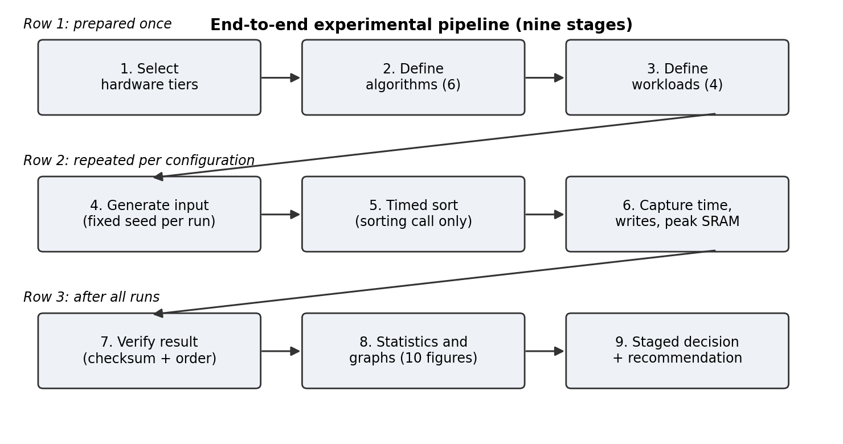
Nine-stage pipeline: select tiers, define algorithms and workloads, generate input, time the sort, capture metrics, verify, analyse, decide.
Figure 1. End-to-end experimental pipeline.

3.2 Workloads and Data Generation
All data are signed 16-bit integers, the native width of the AVR boards [1]. Inputs are generated on the device before the timer starts, from a fixed seed (1234 plus the run index), so every algorithm sorts exactly the same array in a given run and results are reproducible. The sensor-like workload models buffered readings with a slow drift, a repeating sawtooth and small noise, which gives partially ordered data of the kind produced by sensors.
Table 3. Workloads used by the benchmark firmware.
Workload | Definition | Purpose
Random | Uniform integers from 0 to 10,000, duplicates allowed | Typical unordered data
Ascending | A[i] = i | Best case for Bubble and Insertion Sort; worst case for fixed-pivot Quick Sort
Descending | A[i] = N - i - 1 | Worst case for Bubble and Insertion Sort; tests recursion depth
Sensor-like | 5000 + floor(i/8) + 2(i mod 32) + noise in [-15, 15] | Partially ordered buffered readings with drift and noise

Array sizes are 100, 250, 500, 750 and 1,000, the same set as [1]. Random input is repeated eight times and the other inputs three times. There is no train-test split or preprocessing, since the study sorts data rather than learning from it.

3.3 Hardware Platforms and Firmware Architecture
The core experiment uses the three AVR boards of [1], which share a 16 MHz clock and an 8-bit instruction set and differ mainly in SRAM. This isolates the effect of memory from the effect of processor family. A 32-bit Cortex-M board and a Raspberry Pi-class computer are proposed as additional tiers to test whether the AVR ranking carries over.
Table 4. Hardware tiers.
Tier | Platform | Clock | SRAM | Role
1 | Arduino Uno (ATmega328P) | 16 MHz | 2 KB | Most constrained baseline [1]
2 | Arduino Leonardo (ATmega32U4) | 16 MHz | 2.5 KB | Slightly more SRAM, same architecture [1]
3 | Arduino Mega 2560 (ATmega2560) | 16 MHz | 8 KB | Effect of more SRAM within 8-bit AVR [1]
4 (optional) | 32-bit ARM Cortex-M board | Board dependent | Board dependent | Tests whether ranking changes with more memory and speed
5 (optional) | Raspberry Pi-class edge computer | Board dependent | MB to GB | Upper end of edge devices

Figure 2 shows the rig. The firmware contains a workload generator, the sort under test, probes for time, writes and free SRAM, a verifier and a serial reporter. A host PC captures the tab-separated output and runs the analysis script. An optional GPIO trigger pin marks the sorting interval so that an external power monitor can integrate energy over exactly that window.
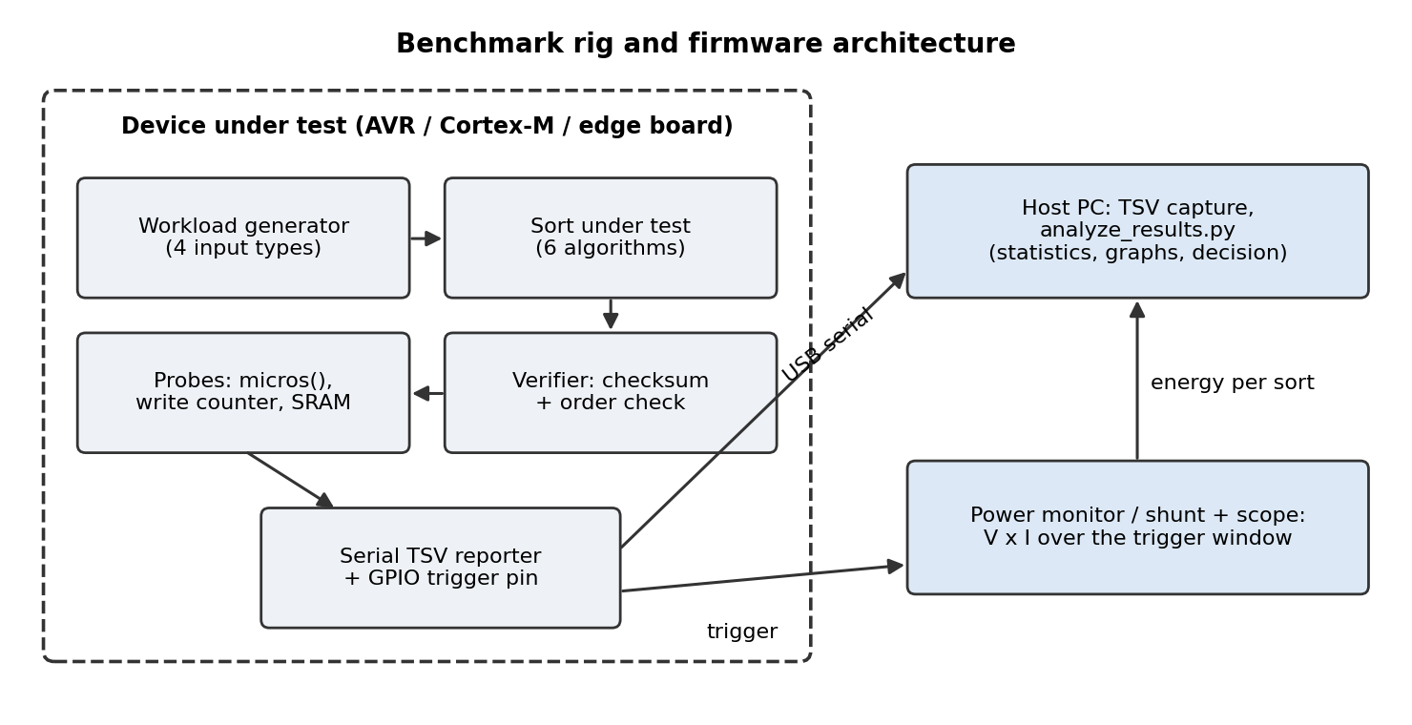
Device under test (generator, sort, probes, verifier, reporter) connected by USB serial to a host PC and by a trigger pin to a power monitor.
Figure 2. Benchmark rig and firmware architecture.
Memory is the first filter. With 2 bytes per element, the array alone takes 2N bytes, and Merge Sort needs a second buffer of the same size. Table 5 shows the arithmetic for a 2 KB board before runtime overhead.
Table 5. SRAM budget on a 2,048-byte board (derived: 2 bytes per element; stack, Serial buffers and runtime are not included, so real limits are lower).
N | Array (bytes) | Array + Merge buffer (bytes) | Free after array (bytes) | Free after array + Merge buffer (bytes)
100 | 200 | 400 | 1,848 | 1,648
250 | 500 | 1,000 | 1,548 | 1,048
500 | 1,000 | 2,000 | 1,048 | 48
750 | 1,500 | 3,000 | 548 | -952 (does not fit)
1,000 | 2,000 | 4,000 | 48 | -1,952 (does not fit)

3.4 Algorithms Used
The six algorithms are plain textbook versions, deliberately not tuned, so that the benchmark shows natural behaviour [1]. Table 6 lists their complexity and memory, and the implementation choices that matter for the results.
Table 6. Algorithms implemented in the benchmark firmware.
Algorithm | Time (best / average / worst) | Extra memory | Implementation choice in the firmware
Bubble Sort | O(n) / O(n²) / O(n²) | O(1) | Early exit when a pass makes no swap
Insertion Sort | O(n) / O(n²) / O(n²) | O(1) | Shifts elements; one final write only if the key moved
Selection Sort | O(n²) in all cases | O(1) | Swap only when the minimum is not already in place
Merge Sort | O(n log n) in all cases | O(n) buffer + recursion | Top-down; copies a range to the buffer and merges back
Quick Sort | O(n log n) / O(n log n) / O(n²) | Recursion, O(n) stack in the worst case | Lomuto partition, last element as pivot, stack guard at 80 bytes
Heap Sort | O(n log n) in all cases | O(1) | Iterative sift-down, fully in place

Each run follows Algorithm 1. Recursive algorithms call a probe on every entry, which samples free SRAM and sets an abort flag if free memory falls below the guard. This turns a stack overflow, which would crash the board, into a recorded failure.
Algorithm 1: Benchmark procedure for one configuration (board, algorithm a, input order o, size N, run r)
1Allocate array A of N 16-bit integers; if allocation fails, record FAIL_ALLOC and stop.
2Fill A according to o using seed 1234 + r.
3Compute the checksum (sum and XOR) of A.
4Set the write counter to 0; F_start = free SRAM; F_min = F_start.
5t0 = micros().
6Sort A with algorithm a; every recursive call updates F_min and sets the abort flag if free SRAM < 80 bytes.
7t = micros() - t0.
8If the abort flag is set, record FAIL_STACK.
9Else recompute the checksum; if it changed or A is not in order, record FAIL_VERIFY; otherwise status = OK.
10M_peak = F_start - F_min.
11Report board, algorithm, o, N, r, t, writes, M_peak and status.

3.5 Mathematical Formulation
For R repeated runs of a configuration with times t_r, the mean and sample standard deviation are given by Equations (1) and (2), and the relative standard deviation (RSD), the measure of timing variation used in [4], by Equation (3).
$μ=\frac{1}{R}\sum_{r=1}^{R}{}t_{r}$(1)
$σ=\sqrt{\frac{1}{R-1}\sum_{r=1}^{R}{}{\left(t_{r}-μ\right)}^{2}}$(2)
$RSD=100×\frac{σ}{μ}$(3)
Speed relative to a reference algorithm (here Bubble Sort) is given by Equation (4), and the relative time reduction by Equation (5).
$S=\frac{T_{ref}}{T_{alg}}$(4)
$ΔT(\%)=100×\frac{T_{ref}-T_{alg}}{T_{ref}}$(5)
Peak extra SRAM is the free memory before sorting minus the minimum free memory observed during sorting, Equation (6). If power is measured over the trigger window, the energy of one sort and the energy per element follow Equation (7) and Equation (8).
$M_{peak}=F_{start}-F_{min}$(6)
$E=\int_{0}^{T}{}V(t)·I(t)dt≈V·I·T$(7)
$E_{elem}=\frac{E}{N}$(8)
Worst-case timing is tracked with the upper outlier bound of [4], Equation (9): runs above Q3 plus 1.5 times the interquartile range are counted as outliers.
$U=Q_{3}+1.5×IQR$(9)
To compare algorithms on several criteria, each is converted to a score between 0 and 1 (Equations (10) to (13)). Here T_min and W_min are the smallest time and write count among algorithms that completed the same configuration, and C is the SRAM capacity of the board. An algorithm that fails a configuration scores 0 on every criterion for that configuration.
$s_{time}=\frac{T_{min}}{T}$(10)
$s_{sram}=1-min\left(\frac{M_{peak}}{C},1\right)$(11)
$s_{writes}=\frac{W_{min}+1}{W+1}$(12)
$s_{stab}=\frac{1}{1+RSD/5}$(13)
The weighted decision score of Equation (14) averages the weighted criterion scores over all configurations c. The weights used by the supplied code are 0.35 for time, 0.25 for SRAM, 0.15 for writes, 0.10 for stability and 0.15 for feasibility, which equals 1 in total. These weights are a design choice and should be changed to match an application.
$S_{avg}=\frac{1}{|C|}\sum_{c=1}^{|C|}{}\sum_{k=1}^{5}{}w_{k}s_{k,c}$(14)
For external sorting, [2] gives the number of merge passes as the ceiling of log base (M-1) of L for external merge sort and log base M of L for NOBsort, where M is the number of memory buffers and L the number of runs. The approximate I/O saving is given by Equation (15) [2].
$ΔIO≈\frac{log M-log(M-1)}{log M}$(15)

3.6 Experimental Setup
Table 7. Experimental setup of the supplied benchmark.
Parameter | Setting
Firmware | Arduino C++ (sorting_benchmark.ino)
Toolchain | Arduino IDE default AVR-GCC with -Os, as in [1]
Data type | Signed 16-bit integers
Array sizes | 100, 250, 500, 750, 1,000
Input orders | Random, ascending, descending, sensor-like
Repetitions | 8 for random input, 3 for the others
Seed | 1234 plus the run index
Timer | micros(); 4 microsecond resolution on a 16 MHz AVR
Memory probe | Free SRAM sampled at the start of every recursive call and at the end
Stack guard | Recursion aborted if free SRAM falls below 80 bytes
Verification | Checksum (sum and XOR) and an order scan
Output | Tab-separated lines at 115,200 baud: board, algorithm, order, N, run, time_us, writes, sram_bytes, status
Status codes | OK, FAIL_ALLOC, FAIL_STACK, FAIL_VERIFY
Analysis | Python 3 with pandas, numpy and matplotlib (analyze_results.py); sample standard deviation
Energy (optional) | GPIO trigger pin and an INA219/INA226 power monitor or oscilloscope

3.7 Evaluation Metrics
Table 8. Metrics used in the evaluation.
Metric | Definition | Better
Execution time | micros() difference around the sort; mean over runs, Equation (1) | Lower
Array writes | Writes to the main array only (not temporaries or loop counters) | Lower
Peak extra SRAM | Equation (6) | Lower
Maximum feasible N | Largest tested N that succeeds for all input orders | Higher
Speed-up | Equation (4), relative to Bubble Sort | Higher
Temporal stability | RSD, Equation (3), and percentage of runs above the outlier bound, Equation (9) | Lower
Energy per sort (optional) | Equations (7) and (8) | Lower
Decision score | Equation (14) | Higher

The ten graphs produced by the analysis script correspond to these metrics: run time, writes and SRAM against N, run time by input order, maximum feasible N, a failure map, speed-up over Bubble Sort, a time-versus-memory trade-off, temporal stability and the decision score. Figure 3 shows the staged procedure for choosing an algorithm: infeasible and unstable algorithms are removed first, and the remaining ones are compared and scored.
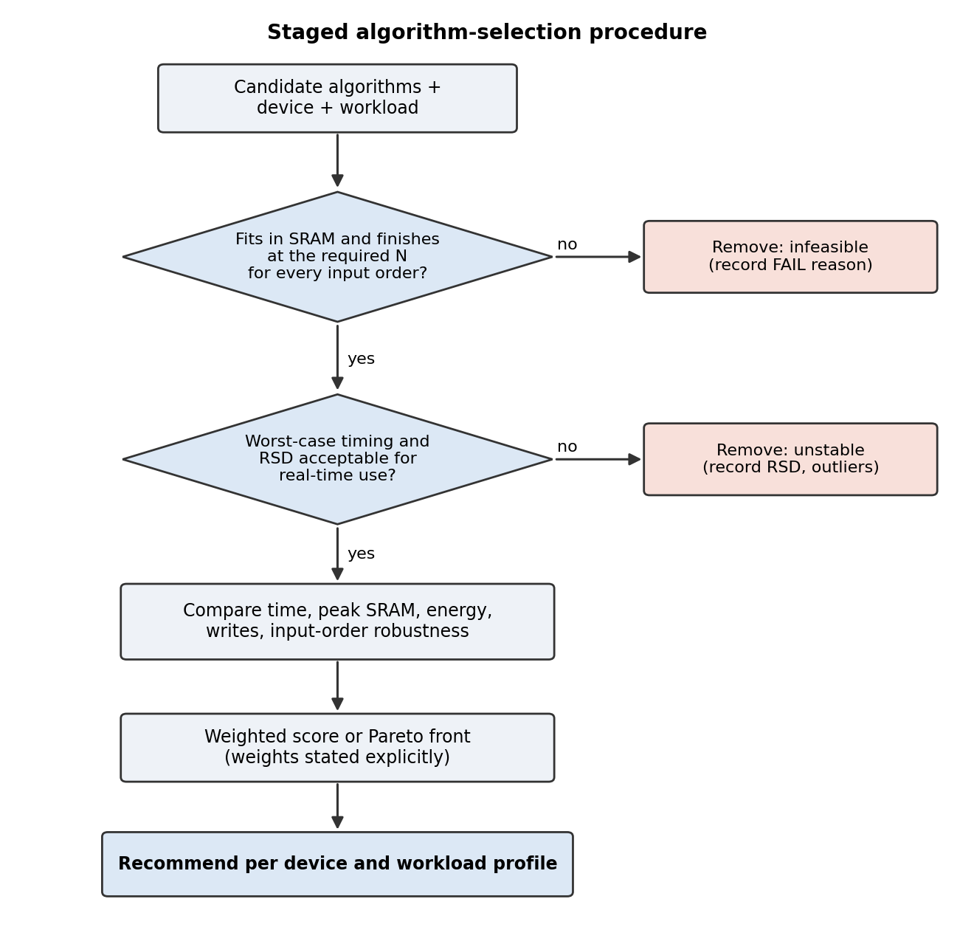
Candidates pass a feasibility test, then a stability test, then are compared on time, SRAM, energy, writes and robustness before a recommendation.
Figure 3. Staged algorithm-selection procedure.

3.8 Fair Comparison Protocol
- Every algorithm sorts the same data in each run because the generator uses fixed seeds.
- All algorithms are built with the same compiler settings, and only the sorting call is inside the timed region.
- Correctness is verified for every run by a checksum and an order scan, so a fast but wrong result is never counted.
- Failures (no memory, stack guard, wrong result) are recorded as outcomes instead of being dropped.
- The same array sizes and input orders are used on every board, and no outliers are removed silently.
- Time is in microseconds and memory in bytes on all boards, so units never differ between tiers.

3.9 Implementation and Reproducibility
Two files are supplied with the paper. The sketch sorting_benchmark.ino implements Section 3 and prints the results over the serial port. The script analyze_results.py reads the saved output and produces the ten graphs, a summary table and a decision table for each board. To reproduce an experiment: set the board name at the top of the sketch, upload it, save the serial output as a .tsv file, and run the script on one file per board. The script also has a --demo option that draws the graphs from synthetic numbers, which is only for testing the plotting code and must not be reported as a measurement.

4. Results and Discussion
How to read this section. The numbers below are values reported in the reviewed studies. They are quoted and plotted without change; ratios and differences computed from printed values are marked derived. The benchmark of Section 3 has been implemented but has not yet been run on hardware, so Table 13 is left to be filled with this paper's own measurements. No figure or number in this paper should be read as our own measurement unless it appears in that table.

4.1 Dataset and Experimental Configuration
Table 9 summarises how each reviewed study was run, because the results in the next subsections are only comparable within the same configuration.
Table 9. Experimental configurations of the reviewed studies.
Study | Platform | Sizes | Inputs | Repeats | Metrics
[1] | Arduino Uno, Leonardo, Mega 2560 (16 MHz) | 100 to 1,000 | Random, ascending, descending | 8 random, 3 ordered | Time, writes, SRAM
[2] | Arduino Mega 2560 + 2 GB microSD | Up to 20,000 blocks | Random, sorted, partly sorted | 5 | I/O count, time
[3] | Workstation (Windows 11, Node.js) | 10² to 10⁹ | Synthetic, taxi, IoT, genomic | 10 (median) | Time, memory
[4] | Intel i7-9850H; FPGA (Vivado HLS) | 8 to 4,096 | 47 permutations | 1,000 per permutation | Time, RSD, outliers
[5] | Intel i7-9750H laptop (C#) | 1,000,000 | Four distributions | 100 | Time, similarity
[7] | Ryzen 5, Core i7, Apple M1 (Python) | Not tabulated here | Random, nearly sorted, reverse | 30 | Time, memory

4.2 Quantitative Comparison
Table 10 gives the 8-bit AVR results of [1] for 1,000 random integers. Speed-ups relative to Bubble Sort are derived from the printed times.
Table 10. Published results of [1] for N = 1,000 random elements (derived speed-up column).
Algorithm | Mean time (ms) | Extra SRAM (bytes) | Speed-up over Bubble Sort (derived)
Bubble Sort | 1,958.2 | 0 | 1.0
Insertion Sort | 973.6 | 0 | 2.0
Selection Sort | 1,014.4 | 0 | 1.9
Merge Sort | 95.9 (Mega 2560) | about 2,023 | 20.4
Quick Sort | 54.3 to 54.6 (Leonardo, Mega) | 303 to 316 | about 36
Heap Sort | 92.4 | 12 to 13 | 21.2

Table 11 gives the FPGA and Intel i7 results of [4] at three array sizes. The i7 times were published in nanoseconds and are converted to microseconds here (derived) so that both platforms share one unit.
Table 11. Published results of [4]: mean time (microseconds; i7 converted from nanoseconds) and RSD (%).
n | Algorithm | i7 time (µs) | i7 RSD (%) | FPGA time (µs) | FPGA RSD (%)
64 | Tim Sort | 0.565 | 29.6 | 50.89 | 6.82
64 | Merge Sort | 0.752 | 6.1 | 58.46 | 5.94
64 | Heap Sort | 0.682 | 5.2 | 52.78 | 6.57
64 | Shell Sort | 0.407 | 6.1 | 60.24 | 5.76
64 | Quick Sort | 0.508 | 71.8 | 62.80 | 5.54
1,024 | Tim Sort | 32.53 | 36.2 | 832.85 | 0.42
1,024 | Merge Sort | 33.14 | 24.0 | 1,031.50 | 0.34
1,024 | Heap Sort | 23.72 | 3.6 | 1,015.50 | 0.40
1,024 | Shell Sort | 40.37 | 29.2 | 1,625.10 | 0.22
1,024 | Quick Sort | 53.52 | 150.1 | 3,121.00 | 0.11
4,096 | Tim Sort | 189.44 | 36.8 | 3,756.00 | 0.09
4,096 | Merge Sort | 183.89 | 27.0 | 4,734.90 | 0.07
4,096 | Heap Sort | 129.83 | 5.4 | 4,848.50 | 0.07
4,096 | Shell Sort | 235.35 | 30.8 | 9,756.40 | 0.04
4,096 | Quick Sort | 641.83 | 209.8 | 38,507.00 | 0.00

Table 12 lists the main published results of the other studies. They use different platforms and data and are not directly comparable with Tables 10 and 11.
Table 12. Other published results.
Study | Result as reported | Conditions
[2] NOBsort | 20% to 35% less I/O and time than external merge sort; theoretical saving 37% (M = 3) and 21% (M = 4); advantage 7% to 15% at M = 6 | Arduino Mega 2560, microSD, small M
[3] Adaptive Hybrid Sort | 0.21 s versus 0.38 s for Timsort at 10⁶ elements and 2.1 s versus 3.8 s at 10⁷ (ratio about 1.8, derived); classifier accuracy 92.4% | Workstation; units inconsistent in the source
[5] Threshold-based sort | Top 5% of uniform data: Merge 15.9 ms versus 163 ms (10.3 times, derived), Quick 14.1 ms versus 214 ms (15.2 times, derived) | 1,000,000 elements, known distribution, i7 laptop
[7] Desktop study | Tim Sort 6 ms and 7.80 MB; Merge up to 28 ms and 8.34 MB; Intro 11 to 13 ms | Three laptops, Python, 30 trials

Table 13 is the slot for this paper's own measurements. It should be completed from the summary file written by analyze_results.py after the benchmark has been run on the boards.
Table 13. Own measurements (to be completed after running the benchmark; no values have been measured yet).
Algorithm | Uno N=500: time (ms) | Uno N=500: writes | Uno N=500: SRAM (B) | Mega N=1,000: time (ms) | Mega N=1,000: writes | Mega N=1,000: SRAM (B)
Bubble Sort | - | - | - | - | - | -
Insertion Sort | - | - | - | - | - | -
Selection Sort | - | - | - | - | - | -
Merge Sort | - | - | - | - | - | -
Quick Sort | - | - | - | - | - | -
Heap Sort | - | - | - | - | - | -

4.3 Execution-Time Analysis
On the 8-bit boards, the three quadratic algorithms are within a factor of about two of each other at N = 1,000, while the three O(n log n) algorithms are 20 to 36 times faster than Bubble Sort (Table 10, derived). Quick Sort is fastest on random data, and Heap and Merge Sort are close to each other [1].
The platform changes the picture. On the i7, Heap Sort is fastest at 1,024 and 4,096 elements, and Quick Sort at 4,096 is about 4.9 times slower than Heap Sort (derived from Table 11). On the FPGA, Tim Sort is fastest from 128 elements upward [4]. For the same algorithm and size, the FPGA is much slower than the i7: at 4,096 elements, between about 20 times for Tim Sort and about 60 times for Quick Sort (derived from Table 11). Despite a much lower clock frequency, the authors describe FPGA times as respectable because high-level synthesis extracts parallelism from the algorithms [4].
When only a part of the data is needed, avoiding the full sort pays off more than choosing a faster full sort: the threshold-based method was 10 to 15 times faster than the conventional approach for the top 5% of 1,000,000 values (derived from [5]). For data held in flash, reducing merge passes gives 20% to 35% savings at small memory [2].

4.4 Memory and Write Analysis
Memory separates the algorithms more sharply than time on the smallest boards. At N = 1,000, Merge Sort needed about 2,023 bytes of extra SRAM and Heap Sort only 12 to 13 bytes, a difference of more than 150 times (derived), while Heap and Merge Sort were within 4% of each other in time (derived from Table 10). Because the array itself takes 2,000 bytes at N = 1,000 (Table 5), a 2 KB board has almost no room left, and Merge Sort cannot run at the larger sizes. Quick Sort used about 310 bytes on random input, but recursion depth grew on ordered input and it failed [1].
Write counts show a different ordering. Selection Sort wrote very little and predictably whatever the input. Bubble Sort wrote nothing on already-sorted input and Insertion Sort wrote N - 1 elements, but both wrote a great deal on random and reversed input [1]. Writes matter for flash wear and energy, and NOBsort's reduction of I/O also reduces writes to flash [2]. On larger systems memory is reported in megabytes, with Tim Sort lowest at 7.80 MB [7], and the adaptive classifier itself occupies 1 MB [3]. Such budgets are irrelevant on the AVR boards.

4.5 Scalability and Input-Order Analysis
Input order changed the ranking in every study that tested it. On the AVR boards, Bubble and Insertion Sort became extremely fast on ascending input because little data moves, while fixed-pivot Quick Sort degraded and failed; on descending input Heap and Merge Sort stayed fast and Selection Sort stayed at its quadratic time [1]. On desktop machines, Quick Sort used much memory on reversed input [7]. For external sorting, replacement selection reduces sorted data to a single run and, for random data, roughly halves the number of runs, which matters most for nearly sorted sensor data [2].
Array size also changes the winner. On the i7 the fastest algorithm was Tim Sort up to 32 elements, Shell Sort at 64 and 128, Tim Sort at 256 and Heap Sort from 1,024 upward, with 512 elements undecided between Merge and Heap Sort [4]. Adaptive selection formalises this by switching algorithm on size, key range and entropy [3]. The sensor-like workload of this paper has not been measured by any reviewed study on a microcontroller, so its effect remains open.

4.6 Graphs and Visualizations
Figures 4 to 6 are redrawn from the numbers printed in the reviewed studies. They are not new measurements. Figure 4 shows the 8-bit results of [1], Figure 5 the i7 and FPGA results of [4], and Figure 6 the threshold-based results of [5]. After the benchmark is run, the ten graphs of the analysis script replace and extend them.
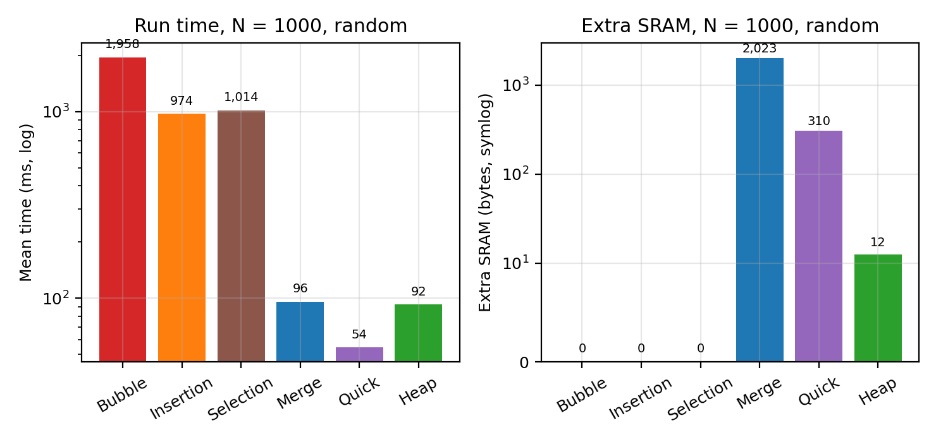
Run time (log scale) and extra SRAM (symmetric log scale) for six algorithms at N = 1,000 random elements.
Figure 4. Published 8-bit AVR results of [1]; Quick Sort values are midpoints of the reported ranges.
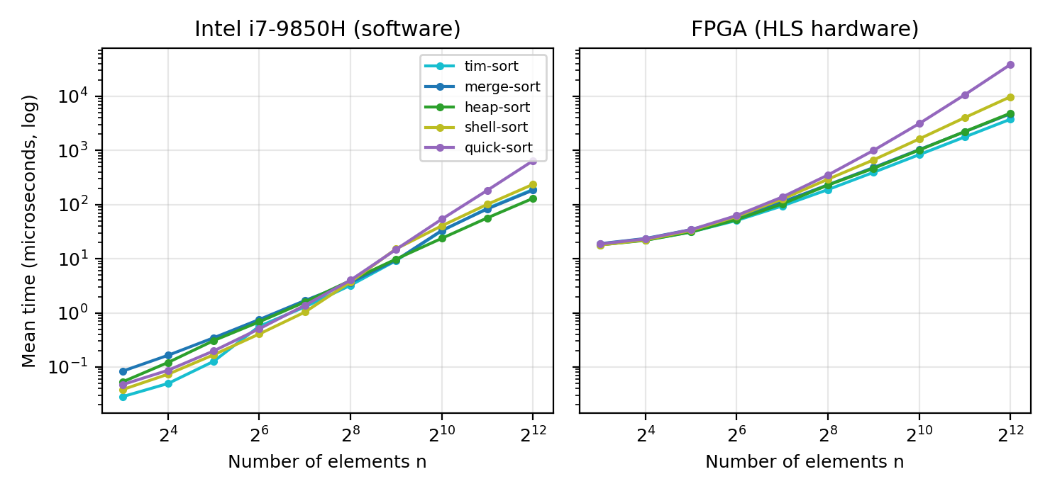
Mean time (log scale) against number of elements for five algorithms, Intel i7 (left) and FPGA (right), in microseconds.
Figure 5. Published results of [4]; i7 values converted from nanoseconds to microseconds.
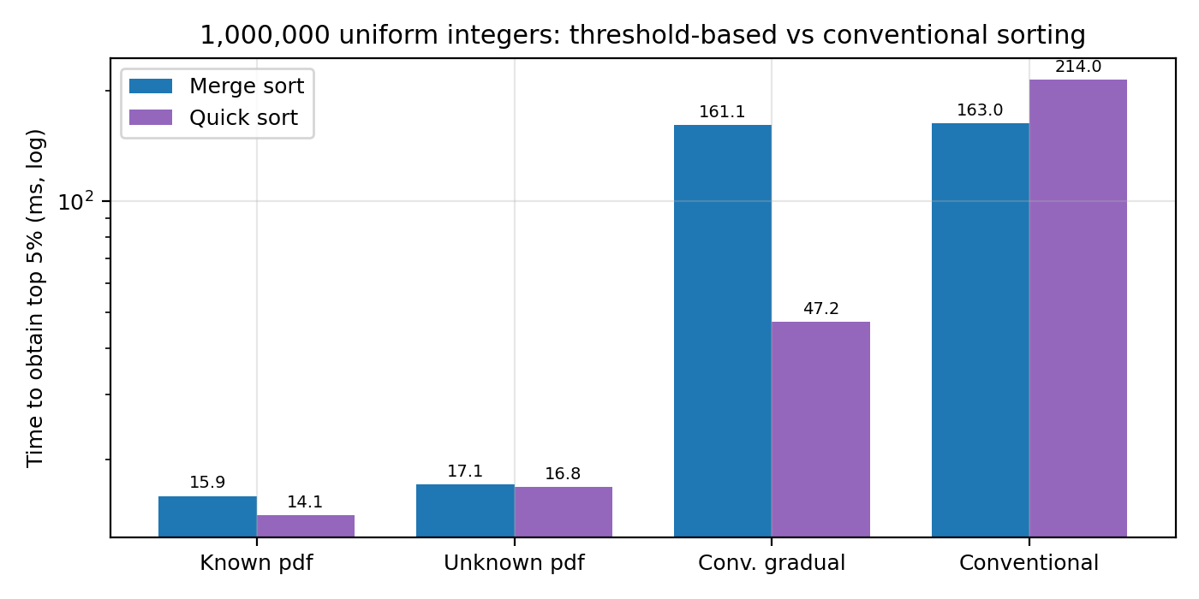
Time to obtain the top 5% of 1,000,000 uniform integers for Merge and Quick Sort with four methods (log scale).
Figure 6. Published results of [5] for uniform data.

4.7 Statistical Analysis
The reviewed studies use different statistical protocols (Table 14). The design of [4] is the most complete: 47 permutations per size with 1,000 replications each, RSD, confidence intervals, outlier percentages, a Shapiro-Wilk normality test (the data were not normal), a Kruskal-Wallis test and Wilcoxon pairwise tests with Bonferroni correction, at most 160 tests in total. Study [7] used 30 trials with ANOVA and Tukey's test (p below 0.001).
Table 14. Statistical protocols in the reviewed studies.
Study | Repeats | Statistics
[1] | 8 random, 3 ordered | Mean and standard deviation; no outliers removed
[2] | 5 | Average of runs
[4] | 47 permutations x 1,000 | RSD, confidence interval, outliers, Shapiro-Wilk, Kruskal-Wallis, Wilcoxon (Bonferroni)
[5] | 100 | Average time and similarity measure
[7] | 30 | Shapiro-Wilk, one-way ANOVA, Tukey HSD

No new statistical tests are computed in this paper because it contains no new data. The supplied analysis script reports the mean, sample standard deviation, RSD and outlier percentage. With 8 random and 3 ordered repeats, as in [1], these are descriptive; for inference we recommend at least 30 repeats and non-parametric tests, following [4] and [7].

4.8 Comparison with Existing Literature
Table 15. Where each study found a particular approach best.
Study | Setting | Reported best
[1] | 8-bit AVR, in memory | Heap Sort most balanced; Quick Sort fastest on random but unreliable; Bubble and Insertion Sort fastest on ascending input
[2] | Flash/SD, M of 2 to 4 buffers | NOBsort; MinSort when few distinct keys
[3] | Workstation, by data features | Counting (small range), Radix (large range), Quick otherwise
[4] | Intel i7 | Tim Sort for small n, Shell for medium n, Heap Sort for n of 1,024 and above
[4] | FPGA | Tim Sort for n above 64, and most stable
[5] | Need only part of the data | Threshold-based partial sorting
[7] | Laptops, Python | Tim Sort for time and memory

Heap Sort appears as a robust choice in the studies that include it on small or constrained systems: it is the most balanced on 8-bit boards [1] and the fastest and most stable of the five on the i7 above 1,000 elements [4]. Tim Sort wins on the FPGA [4] and on laptops [7], where memory is not the limiting factor. These results do not contradict each other, because the platforms, data and criteria differ, which is the point of the paper: the best algorithm depends on the device.

4.9 Discussion of Research Questions and Hypotheses
The status below is based on published evidence only. Each item must be confirmed or rejected with this paper's own measurements.
- RQ1 (largest feasible size). Published evidence shows that configurations which do not fit in SRAM fail, and that Merge Sort fails at larger sizes on the smaller boards [1]. The actual limits for the supplied firmware are not yet measured.
- RQ2 (trade-offs). At N = 1,000 the O(n log n) algorithms are 20 to 36 times faster than Bubble Sort, but Merge Sort needs about 2 KB of extra memory and Quick Sort about 300 bytes, against 12 to 13 bytes for Heap Sort [1] (Table 10, derived).
- RQ3 (robust default). Heap Sort is the most balanced on 8-bit boards [1] and the most stable of the fast algorithms on the i7 [4]. This suggests Heap Sort as the default, to be confirmed on our data.
- RQ4 (portability of the ranking). Not portable: the winner differs between the i7 and the FPGA [4], and Tim Sort wins on desktop machines [7].
- H1. Supported in outline by [1]: Heap Sort completed every configuration that fit, Merge Sort failed on memory, Quick Sort failed on ordered input and the other three are quadratic. Not yet tested by us.
- H2. Supported by [1] (Merge Sort failed at larger sizes on smaller boards) and by the arithmetic of Table 5.
- H3. Supported by [1] (failures on ordered input) and by [4] (RSD of 209.8% at 4,096 elements on the i7).
- H4. Supported by the cross-study evidence of Tables 11 and 15.

4.10 Limitations and Threats to Validity
- No new measurements. Results are taken from published studies on different platforms, so cross-study comparisons are indicative only.
- Source quality varies. The adaptive-sorting manuscript [3] has unit inconsistencies and no stated venue, so its figures need independent confirmation.
- Derived numbers. Ratios and unit conversions were calculated from printed values and inherit their rounding; the Quick Sort values in Table 10 are ranges.
- Hardware scope. The core design covers 8-bit AVR boards; 32-bit and edge tiers, floating-point data, external memory and direct energy measurement are proposed but not yet done.
- Measurement effects. The 4-microsecond timer resolution of micros() limits very short runs, compiler flags and board variation affect timing, and on larger systems operating-system noise adds variation.
- Few repeats. Eight and three repeats support description, not strong inference.

5. Conclusion
This paper reviewed seven studies on sorting for constrained, embedded and hardware platforms, compared them, and identified a gap: no reviewed study combines multi-tier hardware, direct energy measurement, sensor-like workloads and an explicit decision framework. It specified a reproducible benchmark and supplied the firmware and analysis code. The published evidence shows that practical sorting efficiency on constrained devices is governed by memory, input order and timing stability as much as by time complexity: on 8-bit boards Heap Sort was the most balanced algorithm, Merge Sort was limited by memory, and Quick Sort was unreliable on ordered input, while on other platforms different algorithms won.
The main limitation is that the paper's own measurements have not yet been collected. The next steps are to run the benchmark on the Uno, Leonardo and Mega 2560, complete Table 13 and replace Figures 4 to 6 with the ten graphs of the analysis script, then add a 32-bit board, energy measurement and the optional external-memory mode. The decision procedure of Section 3.7 can then be applied to the measured data to recommend an algorithm for each device and workload.

6. References
[1]J. Golonka and F. Kružel, "Empirical evaluation of unoptimized sorting algorithms on 8-bit AVR Arduino microcontrollers," Sensors, vol. 26, art. 214, 2026, doi: 10.3390/s26010214.
[2]R. Jackson, J. Gresl and R. Lawrence, "Efficient external sorting for memory-constrained embedded devices with flash memory," ACM Trans. Embed. Comput. Syst., vol. 20, no. 4, art. 29, Mar. 2021, doi: 10.1145/3446976.
[3]S. A. Balasubramanian, "Adaptive Hybrid Sort: Dynamic strategy selection for optimal sorting across diverse data distributions," manuscript, independent researcher, 2025 (venue not stated in the supplied file).
[4]Y. Ben-Jmaa and D. Duvivier, "Sorting algorithms comparison on FPGA and Intel i7 architectures," Computación y Sistemas, vol. 28, no. 3, pp. 1041-1061, 2024, doi: 10.13053/CyS-28-3-4870.
[5]S. Shirvani Moghaddam and K. Shirvani Moghaddam, "A threshold-based sorting algorithm for dense wireless sensor systems and communication networks," IET Wireless Sens. Syst., vol. 13, no. 2, pp. 37-47, 2023, doi: 10.1049/wss2.12048.
[6]A. Jalilvand, F. S. Banitaba, S. N. Estiri, S. Aygun and M. H. Najafi, "Sorting it out in hardware: A state-of-the-art survey," ACM Trans. Des. Autom. Electron. Syst., vol. 30, no. 4, art. 52, Jun. 2025, doi: 10.1145/3734797.
[7]S. Akobre, J. K. Wiredu, I. Aabaah and U. A. Wumpini, "From theory to application: Evaluating the efficiency, scalability and predictability of classical and modern sorting algorithms in real-time systems," Asian J. Res. Comput. Sci., vol. 18, no. 10, pp. 143-169, 2025, doi: 10.9734/ajrcos/2025/v18i10770.
[8]T. Cossentine and R. Lawrence, "Fast sorting on flash memory sensor nodes," in Proc. 14th Int. Database Eng. Appl. Symp. (IDEAS), New York, NY, USA: ACM, 2010, pp. 105-113, doi: 10.1145/1866480.1866496.
[9]P. Andreou, O. Spanos, D. Zeinalipour-Yazti, G. Samaras and P. K. Chrysanthis, "FSort: External sorting on flash-based sensor devices," in Data Management for Sensor Networks (DMSN'09), 2009, pp. 1-6.
[10]H. Park and K. Shim, "FAST: Flash-aware external sorting for mobile database systems," J. Syst. Softw., vol. 82, no. 8, pp. 1298-1312, 2009.
[11]A. Laga, J. Boukhobza, F. Singhoff and M. Koskas, "MONTRES: Merge on-the-run external sorting algorithm for large data volumes on SSD based storage systems," IEEE Trans. Comput., vol. 66, no. 10, pp. 1689-1702, Oct. 2017, doi: 10.1109/TC.2017.2706678.
[12]M. A. Goetz, "Internal and tape sorting using the replacement-selection technique," Commun. ACM, vol. 6, no. 5, pp. 201-206, 1963.
[13]G. Graefe, "Implementing sorting in database systems," ACM Comput. Surv., vol. 38, no. 3, art. 10, Sep. 2006.
[14]S. R. Madden, M. J. Franklin, J. M. Hellerstein and W. Hong, "TinyDB: An acquisitional query processing system for sensor networks," ACM Trans. Database Syst., vol. 30, no. 1, pp. 122-173, Mar. 2005.
[15]Y. Ben-Jmaa, R. Ben-Atitallah, D. Duvivier and M. Ben-Jemaa, "A comparative study of sorting algorithms with FPGA acceleration by high level synthesis," Computación y Sistemas, vol. 23, no. 1, pp. 213-230, 2019, doi: 10.13053/cys-23-1-2999.
[16]Y. Ben-Jmaa, D. Duvivier and M. Abid, "ARM vs FPGA: Comparative analysis of sorting algorithms," Lect. Notes Netw. Syst., pp. 275-287, 2022, doi: 10.1007/978-3-030-99619-2_27.
[17]N. Auger, V. Jugé, C. Nicaud and C. Pivoteau, "Analysis of timsort algorithm," Laboratoire d'Informatique Gaspard-Monge, 2020.
[18]M. H. Kirkeby et al., "Energy consumption and performance of heapsort in hardware and software," arXiv, pp. 1-3, 2022.
[19]S. Shirvani Moghaddam and K. Shirvani Moghaddam, "On the performance of mean-based sort for large data sets," IEEE Access, vol. 9, pp. 37418-37430, 2021.
[20]S. Shirvani Moghaddam and K. Shirvani Moghaddam, "A general framework for sorting large data sets using independent subarrays of approximately equal length," IEEE Access, vol. 10, pp. 11584-11607, 2022.
[21]L. Atzori, A. Iera and G. Morabito, "The Internet of Things: A survey," Comput. Netw., vol. 54, no. 15, pp. 2787-2805, 2010.
[22]J. Gubbi, R. Buyya, S. Marusic and M. Palaniswami, "Internet of Things (IoT): A vision, architectural elements, and future directions," Future Gener. Comput. Syst., vol. 29, no. 7, pp. 1645-1660, 2013.
[23]I. F. Akyildiz, W. Su, Y. Sankarasubramaniam and E. Cayirci, "Wireless sensor networks: A survey," Comput. Netw., vol. 38, no. 4, pp. 393-422, 2002.
[24]W. Shi, J. Cao, Q. Zhang, Y. Li and L. Xu, "Edge computing: Vision and challenges," IEEE Internet Things J., vol. 3, no. 5, pp. 637-646, Oct. 2016.
[25]M. Satyanarayanan, "The emergence of edge computing," Computer, vol. 50, no. 1, pp. 30-39, Jan. 2017.
[26]J. Hill, R. Szewczyk, A. Woo, S. Hollar, D. Culler and K. Pister, "System architecture directions for networked sensors," in Proc. 9th Int. Conf. Archit. Support Program. Lang. Oper. Syst. (ASPLOS-IX), 2000, pp. 93-104.
[27]P. Levis et al., "TinyOS: An operating system for sensor networks," in Ambient Intelligence. Berlin, Germany: Springer, 2005, pp. 115-148.
[28]D. Gay, P. Levis, R. von Behren, M. Welsh, E. Brewer and D. Culler, "The nesC language: A holistic approach to networked embedded systems," in Proc. ACM SIGPLAN Conf. Program. Lang. Design Implement. (PLDI), 2003, pp. 1-11.
[29]S. Madden, M. J. Franklin, J. M. Hellerstein and W. Hong, "TAG: A tiny aggregation service for ad-hoc sensor networks," ACM SIGOPS Oper. Syst. Rev., vol. 36, special issue, pp. 131-146, 2002.
[30]Y. Yao and J. Gehrke, "The Cougar approach to in-network query processing in sensor networks," ACM SIGMOD Rec., vol. 31, no. 3, pp. 9-18, Sep. 2002.
[31]G. Mathur, P. Desnoyers, D. Ganesan and P. Shenoy, "Capsule: An energy-optimized object storage system for memory-constrained sensor devices," in Proc. 4th ACM Conf. Embedded Netw. Sensor Syst. (SenSys), 2006, pp. 195-208.
[32]N. Tsiftes and A. Dunkels, "A database in every sensor," in Proc. 9th ACM Conf. Embedded Netw. Sensor Syst. (SenSys), 2011, pp. 316-329.
[33]P. Warden and D. Situnayake, TinyML: Machine Learning with TensorFlow Lite on Arduino and Ultra-Low-Power Microcontrollers. Sebastopol, CA, USA: O'Reilly Media, 2019.
[34]R. David et al., "TensorFlow Lite Micro: Embedded machine learning for TinyML systems," in Proc. Mach. Learn. Syst. (MLSys), vol. 3, 2021, pp. 800-811.
[35]C. R. Banbury et al., "MLPerf Tiny benchmark," in Proc. NeurIPS Datasets Benchmarks Track, 2021, arXiv:2106.07597.
[36]M. R. Guthaus, J. S. Ringenberg, D. Ernst, T. M. Austin, T. Mudge and R. B. Brown, "MiBench: A free, commercially representative embedded benchmark suite," in Proc. IEEE 4th Annu. Workshop Workload Characterization, 2001, pp. 3-14.
[37]J. Pallister, S. J. Hollis and J. Bennett, "BEEBS: Open benchmarks for energy measurements on embedded platforms," arXiv preprint, arXiv:1308.5174, 2013.
[38]V. Tiwari, S. Malik and A. Wolfe, "Power analysis of embedded software: A first step towards software power minimization," IEEE Trans. Very Large Scale Integr. (VLSI) Syst., vol. 2, no. 4, pp. 437-445, Dec. 1994.
[39]R. Pereira et al., "Energy efficiency across programming languages: How do energy, time, and memory relate?" in Proc. 10th ACM SIGPLAN Int. Conf. Softw. Lang. Eng. (SLE), 2017, pp. 256-267.
[40]D. E. Knuth, The Art of Computer Programming, Vol. 3: Sorting and Searching, 2nd ed. Reading, MA, USA: Addison-Wesley, 1998.
[41]T. H. Cormen, C. E. Leiserson, R. L. Rivest and C. Stein, Introduction to Algorithms, 4th ed. Cambridge, MA, USA: MIT Press, 2022.
[42]O. Astrachan, "Bubble sort: An archaeological algorithmic analysis," in Proc. 34th SIGCSE Tech. Symp. Comput. Sci. Educ., 2003, pp. 1-5.
[43]C. A. R. Hoare, "Algorithm 64: Quicksort," Commun. ACM, vol. 4, no. 7, p. 321, 1961.
[44]R. Sedgewick, "Implementing quicksort programs," Commun. ACM, vol. 21, no. 10, pp. 847-857, 1978.
[45]J. L. Bentley and M. D. McIlroy, "Engineering a sort function," Softw. Pract. Exper., vol. 23, no. 11, pp. 1249-1265, 1993.
[46]D. R. Musser, "Introspective sorting and selection algorithms," Softw. Pract. Exper., vol. 27, no. 8, pp. 983-993, 1997.
[47]J. W. J. Williams, "Algorithm 232: Heapsort," Commun. ACM, vol. 7, no. 6, pp. 347-348, 1964.
[48]R. W. Floyd, "Algorithm 245: Treesort 3," Commun. ACM, vol. 7, no. 12, p. 701, 1964.
[49]E. W. Dijkstra, "Smoothsort, an alternative for sorting in situ," Sci. Comput. Program., vol. 1, no. 3, pp. 223-233, 1982.
[50]D. L. Shell, "A high-speed sorting procedure," Commun. ACM, vol. 2, no. 7, pp. 30-32, 1959.
[51]R. Sedgewick, "Analysis of Shellsort and related algorithms," in Algorithms - ESA '96, Lecture Notes in Computer Science, vol. 1136. Berlin, Germany: Springer, 1996, pp. 1-11.
[52]M. Ciura, "Best increments for the average case of Shellsort," in Fundamentals of Computation Theory (FCT 2001), Lecture Notes in Computer Science, vol. 2138. Berlin, Germany: Springer, 2001, pp. 106-117.
[53]N. Auger, V. Jugé, C. Nicaud and C. Pivoteau, "On the worst-case complexity of TimSort," in Proc. 26th Annu. Eur. Symp. Algorithms (ESA), LIPIcs, vol. 112, art. 4, 2018.
[54]S. Edelkamp and A. Weiß, "BlockQuicksort: How branch mispredictions don't affect quicksort," in Proc. 24th Annu. Eur. Symp. Algorithms (ESA), LIPIcs, vol. 57, art. 38, 2016.
[55]C. R. Cook and D. J. Kim, "Best sorting algorithm for nearly sorted lists," Commun. ACM, vol. 23, no. 11, pp. 620-624, 1980.
[56]V. Estivill-Castro and D. Wood, "A survey of adaptive sorting algorithms," ACM Comput. Surv., vol. 24, no. 4, pp. 441-476, Dec. 1992.
[57]A. LaMarca and R. E. Ladner, "The influence of caches on the performance of sorting," J. Algorithms, vol. 31, no. 1, pp. 66-104, 1999.
[58]A. Aggarwal and J. S. Vitter, "The input/output complexity of sorting and related problems," Commun. ACM, vol. 31, no. 9, pp. 1116-1127, Sep. 1988.
[59]J. S. Vitter, "External memory algorithms and data structures: Dealing with massive data," ACM Comput. Surv., vol. 33, no. 2, pp. 209-271, Jun. 2001.
[60]P.-A. Larson and G. Graefe, "Memory management during run generation in external sorting," in Proc. ACM SIGMOD Int. Conf. Manage. Data, 1998, pp. 472-483.
[61]K. E. Batcher, "Sorting networks and their applications," in Proc. AFIPS Spring Joint Comput. Conf., 1968, pp. 307-314.
[62]R. Mueller, J. Teubner and G. Alonso, "Sorting networks on FPGAs," VLDB J., vol. 21, no. 1, pp. 1-23, 2012.
[63]D. Koch and J. Torresen, "FPGASort: A high performance sorting architecture exploiting run-time reconfiguration on FPGAs for large problem sorting," in Proc. ACM/SIGDA Int. Symp. Field Programmable Gate Arrays (FPGA), 2011, pp. 45-54.
[64]J. Chhugani et al., "Efficient implementation of sorting on multi-core SIMD CPU architecture," Proc. VLDB Endow., vol. 1, no. 2, pp. 1313-1324, 2008.
[65]N. Satish et al., "Fast sort on CPUs and GPUs: A case for bandwidth oblivious SIMD sort," in Proc. ACM SIGMOD Int. Conf. Manage. Data, 2010, pp. 351-362.

